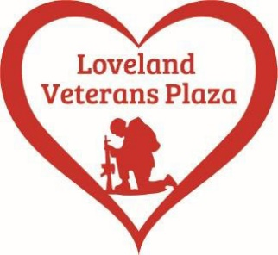

After the May 13th dinner/concert/fundraiser at Ellis Event Center was completed, we were able to catch our breath and move into June. We have set up booths at several events since then in a continuing effort to enhance public awareness of our project. Our sincere thanks to Karen Trupp for planning and hosting another bowling event, with the Loveland Veterans Plaza being the recipient of the proceeds. It was held at Sweetheart Lanes, on June 25^{th.} She packed the house with a total of 111 bowlers for the event and a good time was enjoyed by all.
Mariana Butte Men’s Club will be hosting a golf tournament on August 14th at Mariana Butte. Start time is 7:30 am and it will be a scramble format. Lunch will be included and we will be having a silent auction. Registration is $125.00 per player. To register, e-mail Rick Fischer, rfischer@myactionstaffing.com, or call 970-310-1800. Registration and more details are also on our website, LovelandVeteransPlaza.org. You may also register by mailing a check to 1917 Riverview Drive, Berthoud, CO 80513. Sponsor opportunities for the golf tournament include.
Hole sponsor $200
Lunch sponsor $500
Beverage cart sponsor $500
To become a sponsor contact
Ron Albers 970-980-1268 or
Ed Hart 970-459-7728
Please check the website for updates and thank you for your continued support. Stay safe and have a Happy 4th.
Loveland Veterans Plaza - Thank You For Remembering…Never Forget

